**GAZIANTEP UNIVERSITY MEDICAL FACULTY**

**SEMESTER II COMMITTEE III**

**(CENTRAL NERVOUS SYSTEM LECTURE COMMITTEE) MODULE**

**Anamnesis:** Mr. Hasan, 48-year-old, is brought to the emergency room with the complaints of sudden onset of headache, weakness on the right side, slurred speech, nausea and vomiting. The physician who performed the examination in the ED learned from his relatives that he had hypertension in his history, but that he did not take his medication today. The following findings are detected in the examination of Mr.Hasan, whose right hand is dominant.

**Physical Examination:** Blood pressure 170/100mmHg, general condition moderate, consciousness confused. The patient understands what is spoken, makes an effort to follow orders, but cannot verbally express himself. Muscle strength was found to be 3/5 in the right upper extremity and 4/5 in the right lower extremity. It was observed that the patient had sagging in the right corner of the mouth. When the patient was asked to perform movements such as pursing his lips, smiling, and showing his teeth, it was determined that he was inadequate on the right side and the right sulcus nasolabialis became indistinct. There was sufficient movement on both sides in forehead blending, frowning and blinking. There is an increase in deep tendon reflexes (DTR) on the right side and a loss in the abdominal skin reflex on the right half. Babinski reflex was positive in the right foot. Decreased perception of touch, pain and temperature on the right side. Other systemic examination findings of the patient were normal. Routine examinations were normal. Brain CT was requested.

1. **Comment on the patient's complaints.**
2. **Comment on the patient's physical examination findings.**
3. **Explain the anatomical basis of facial paralysis seen in the patient.**
4. **Explain the anatomical basis of the findings seen on the patient's right side (trunk and extremities).**
5. **According to the localization of the lesion seen in brain CT, which vessel can be considered to be damaged? Relate to the findings.**
6. **Which anatomical and functional areas does A.cerebri media supply?**
7. **What type of speech disorder does the patient have? Explain the anatomical background.**
8. **Which brain layers can be affected histopathologically by the damage in the patient's brain? What are the possible structures that might be affected by this damage?**
9. **In CT imaging, in terms of radiological principles, image formation is basically based on the CT number. What is the concept of “CT number”? What biophysical law is it associated with?**

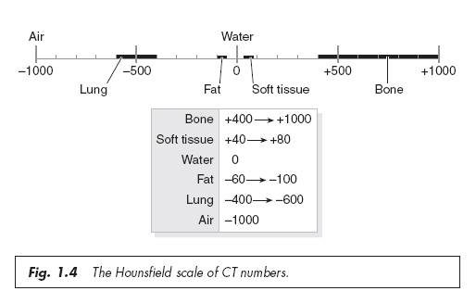

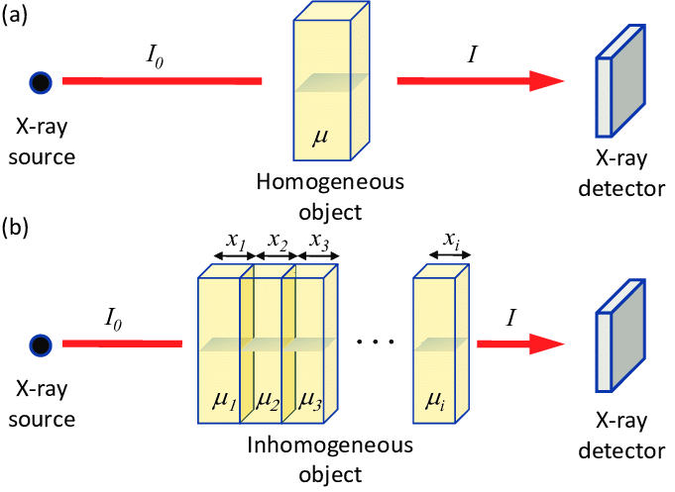



1. **How would you explain the patient's inability to understand what is being said and not be able to express himself verbally? What is the underlying pathophysiological mechanism and where is the affected brain region?**
2. **What is the Babinski reflex, how is it measured, in which situations should it be positive?**
3. **What are your suggestions for his next life?**
4. **What could be the physiological mechanism of the patient's unconsciousness?**
5. **What is the neurophysiological mechanism of the patient's DTR increase, presence of pathological reflex and loss of abdominal skin reflex?**
6. **What is the possible clinical situation in this patient?**
7. **What is the pathology that causes this condition in the patient?**
8. **What could be the lesion seen on brain CT? What should be considered in the differential diagnosis?**

